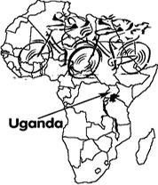**BICYCLE SPONSORSHIP PROJECT AND WORKSHOP**

P.O. Box 1537 Jinja, UGANDA

Tel. +256-434243805

e-mail: bspwbikes@yahoo.com

**BICYCLE SPONSORSHIP PROJECT AND WORKSHOP BICYCLE HANDOVER REPORT TO MOONLIGHT WOMEN GROUP ON MARCH 30, 2022**

**INTRODUCTION:**

**MOONLIGHT WOMEN GROUP** is a women’s group located in Kayunga district, Masembe Village, Namusaala Parish in Busaana Sub-County. The group was registered in 2016 as a community based organization and therefore authorized to perform its activities as laid in their constitution.

The group was formed by a group of five (5) women who saw a great need of supporting each other to eradicate poverty by introducing and participating different income generating activities to improve their households’ standards of living.

The group consists of 60 members and all are women ranging between 30-70 years of age.

The group engages in different activities like; catering services to wedding, funerals e.t.c, knitting table cloth, weaving baskets and mats, farming, piggery, poultry (chicken and ducks), fetching water for sell, cow/goat rearing and savings.

The group is active and fully registered with a leadership and constitution governing them.

1. Chairperson – Songe Selina
2. Secretary – Nyomon Sylvia
3. Treasurer – Gwo Joice

**VISION OF THE GROUP:**

* Poverty alleviation through initiation of viable income generating activities.

**MISSION OF THE GROUP:**

To empower the members of the group economically and socially through a sustainable development.

**OBJECTIVES OF THE GROUP:**

* To fight poverty
* To promote savings and credit co-operation
* To promote community sanitation in Masembe Village

**MAIN ACTIVITIES OF THE GROUP;**

1. Catering services
2. Farming
3. Savings and Credit Co-operation

**ACTIVITIES AS INDIVIDUALS IN THE GROUP:**

Each individual in the group is engaged in one or two of the following activities;

* Primary Teachers (2)
* Tailoring
* Small retail shops
* Poultry keeping
* Boutique (children’s wear)
* Hair dressing
* Knitting
* Farming (pigs, goats)
* Farming (vegetables, maize, beans, cassava, fruits etc)
* Fetching water for selling

**CHALLENGES FACED BY THE GROUP:**

* Lack of transport to markets, health centers, sources of clean water, schools for their children, catering service venues e.t.c

**BICYCLE SPONSORSHIP PROJECT AND WORKSHOP, STEPS IN.**

On October 14, 2021 BSPW received an application letter from Moonlight Women Group requesting for 30 sponsored bicycles to solve their transportation challenges. BSPW did a pre-visit on March 15, 2022 to assess the group’s activeness and need as requested. Thirty (30) bicycles were handed over to 30 beneficiaries.

We believe that incorporating the use of bicycles in their activities will definitely enhance access to home to home visitations, markets, clean sources of water, health Centers, and other income generation activities hence reducing poverty levels and drive to economic transformation.

The group is grateful for the 30 sponsored bicycles that were officially handed over to the beneficiaries on March 30, 2022. The 30 beneficiaries are very grateful to the sponsors for the thoughtfulness and support accorded to them.

**PLANNING AHEAD (FUTURE PLANS):**

* They are in their last process of improving their savings to 3000shs weekly from 1000shs per member.
* Purchasing more tents and plastic chairs (from 50 – 150) and a 100 seater tent
* Learning how to bake cakes (at least 4 members of the group).
* They are organizing to starting up a Poultry as a group.
* They are in the process of purchasing more catering cutlery, tents and plastic chairs.

**REQUEST FROM THE GROUP TO BSPW MANAGEMENT:**

* The group requested to be connected to a person in Jinja who can train them in baking.

***PICTURES IN RECAP:***

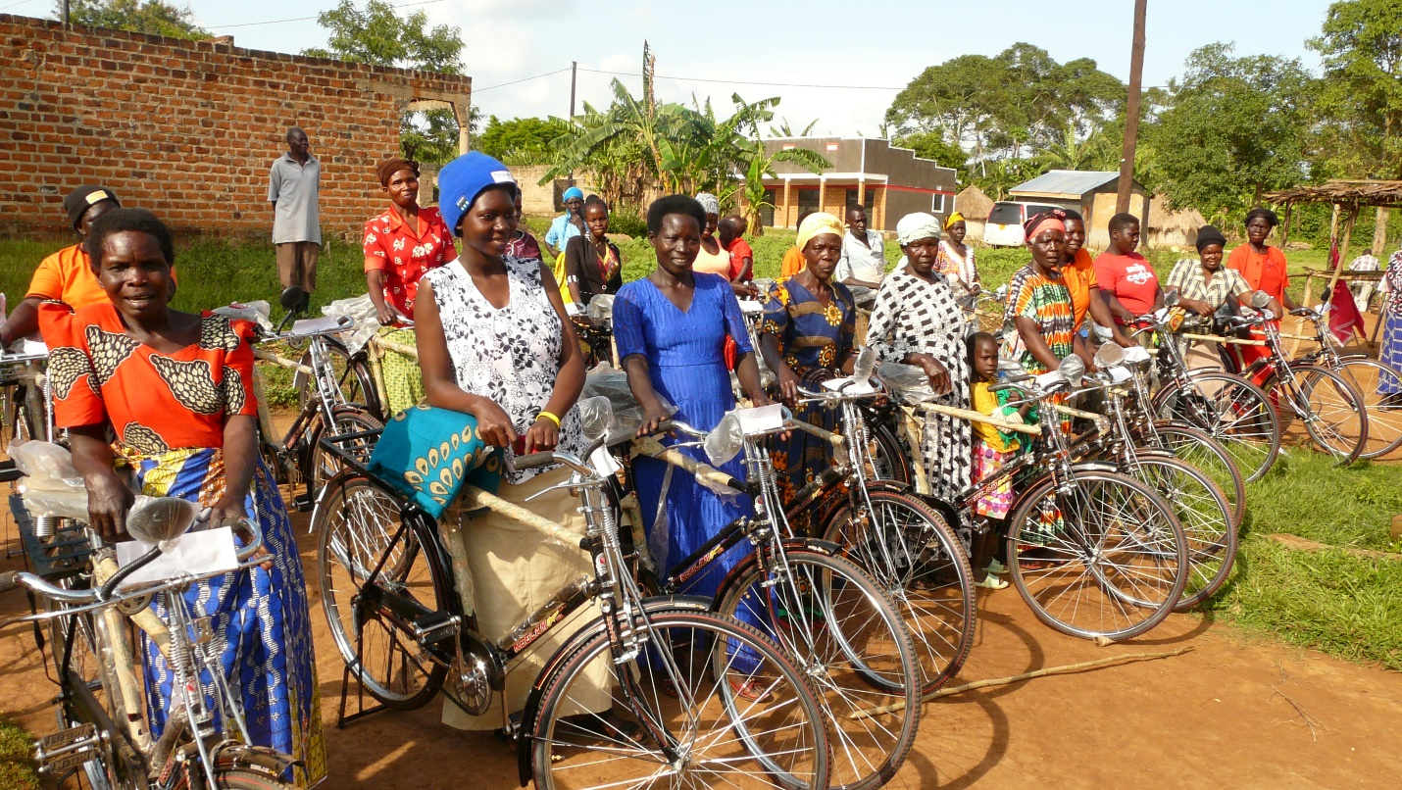

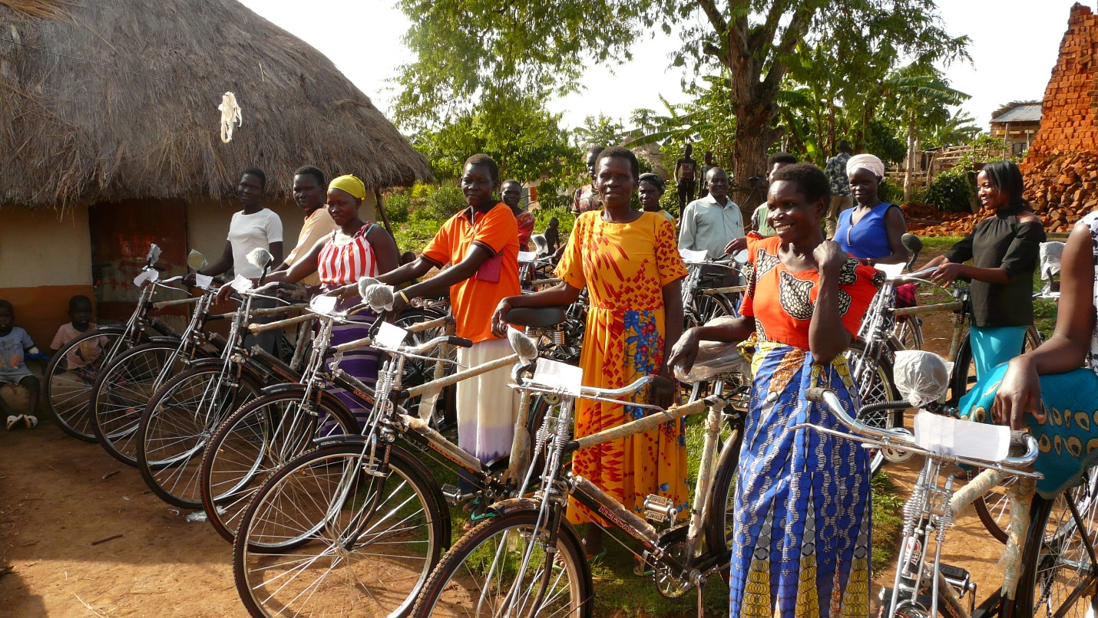

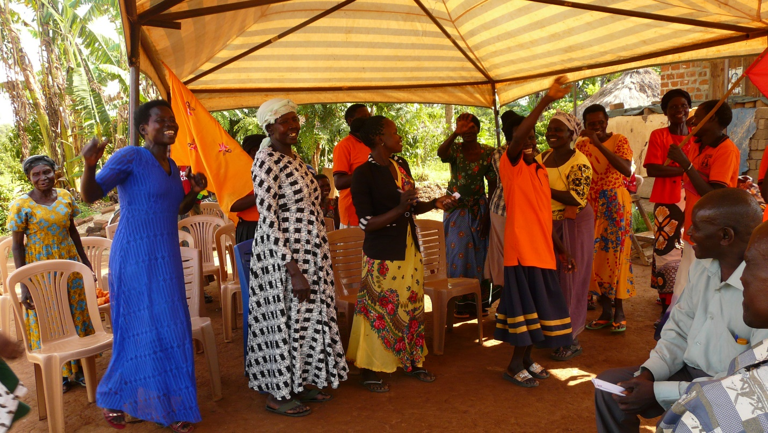

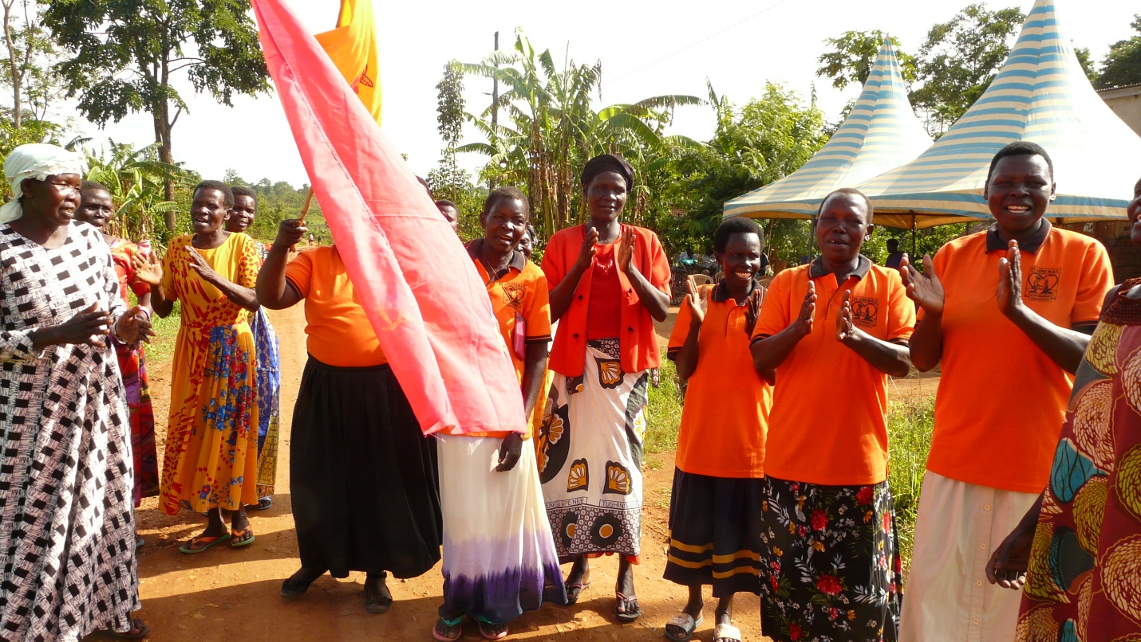

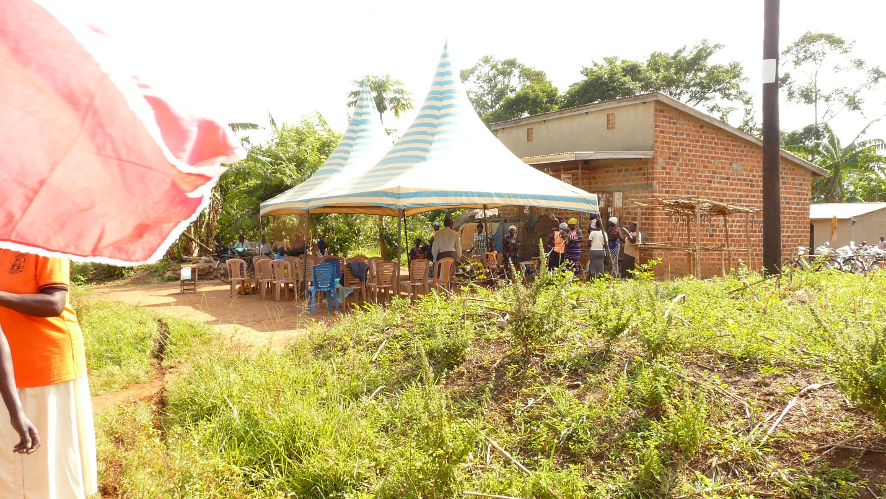

Reported by:

Biira Lovell